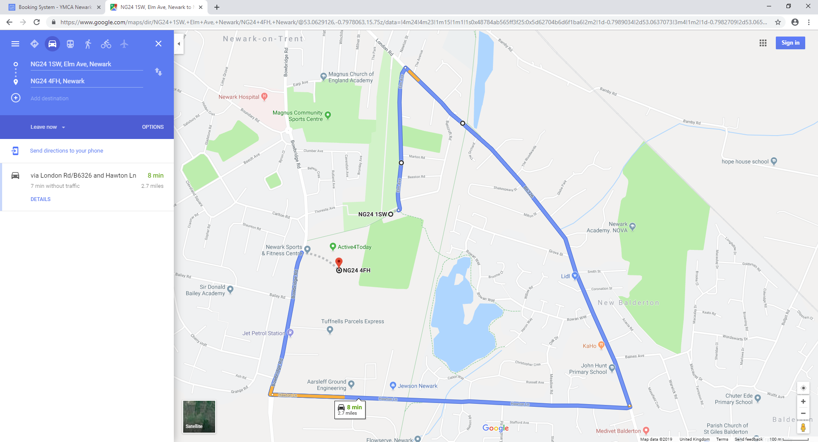

Hawton Lane

London Road

Bowbridge Road



RHP Car Park

Elm Avenue

NG24 1SW